### Lab 6 Experiment with VXLAN

Name: Eduardo Wang Zheng

E-mail: eduardo@sjtu.edu.cn

1. Experiments
   1. Start mininet and set IPs for both hosts

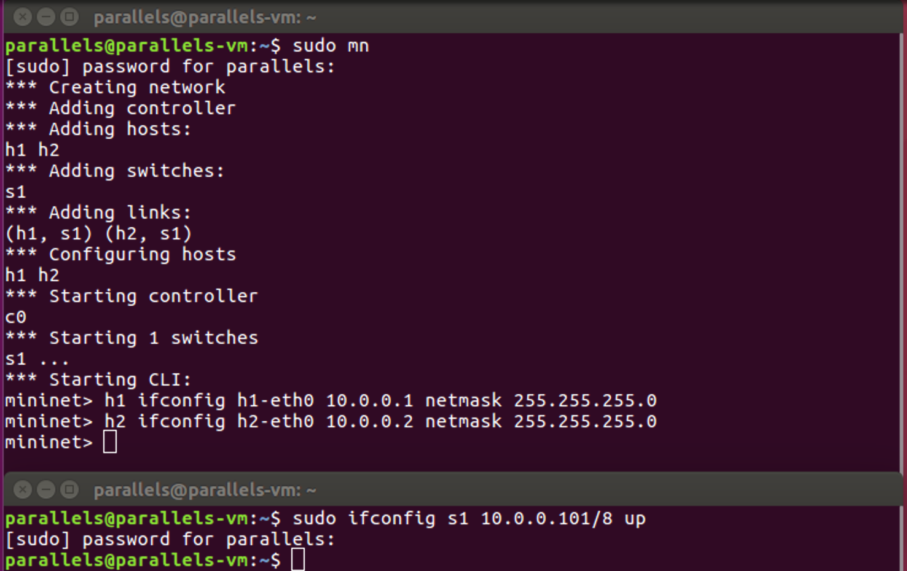

Figure 1 Start mininet and set IPs on VM1

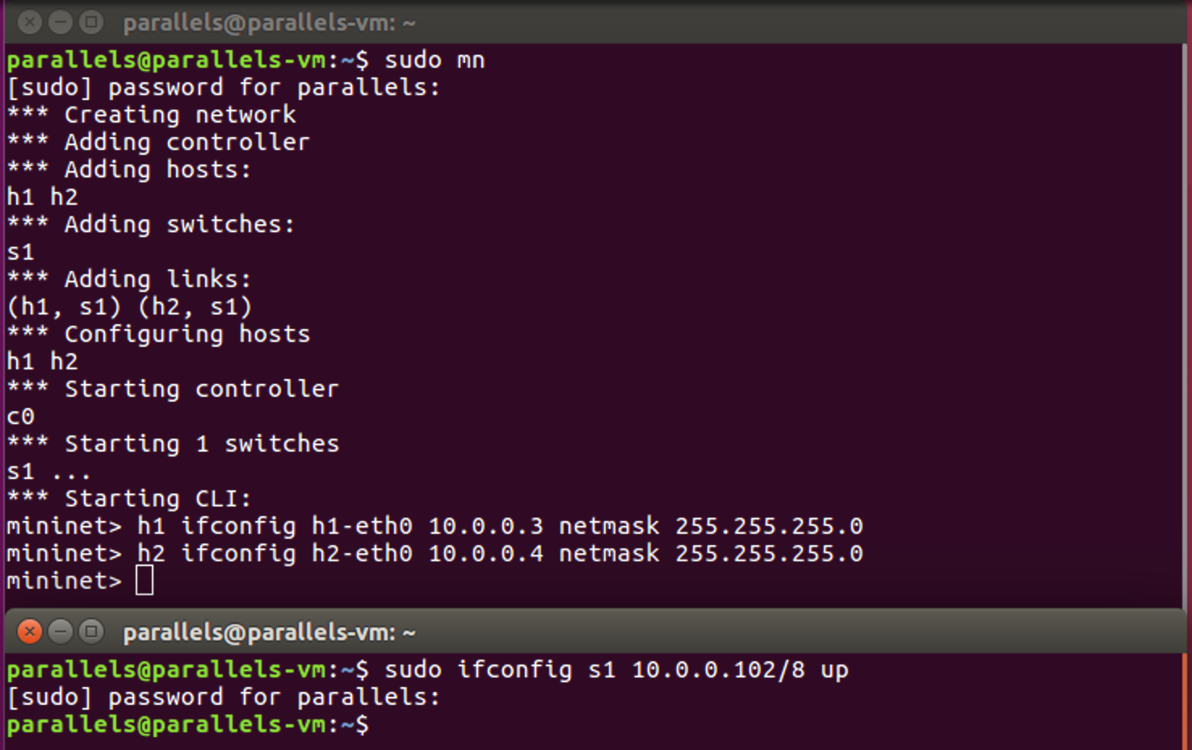

Figure 2 Start mininet and set IPs on VM2

* 1. Assign the IP of enp0s5 to br1 and add a new default route to br1

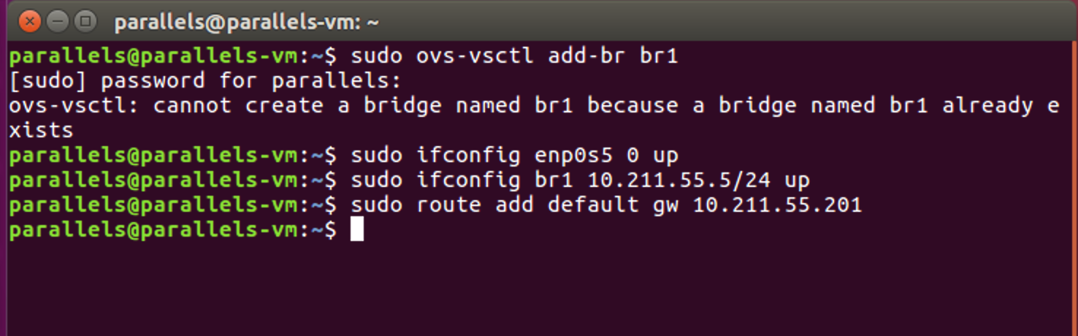

Figure 3 Assign the IP of enp0s5 to br1 and add a new default route to br1 on VM1

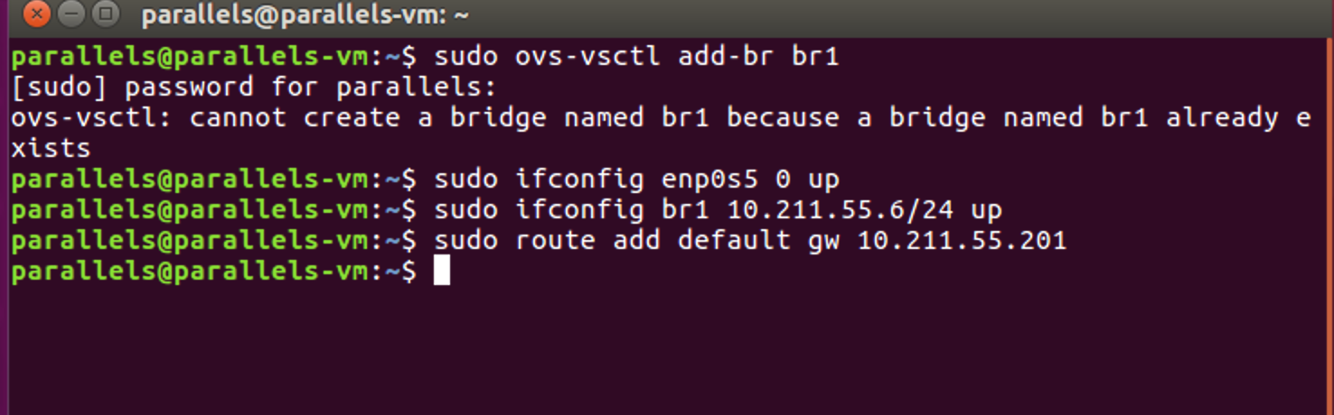

Figure 4 Assign the IP of enp0s5 to br1 and add a new default route to br1 on VM2

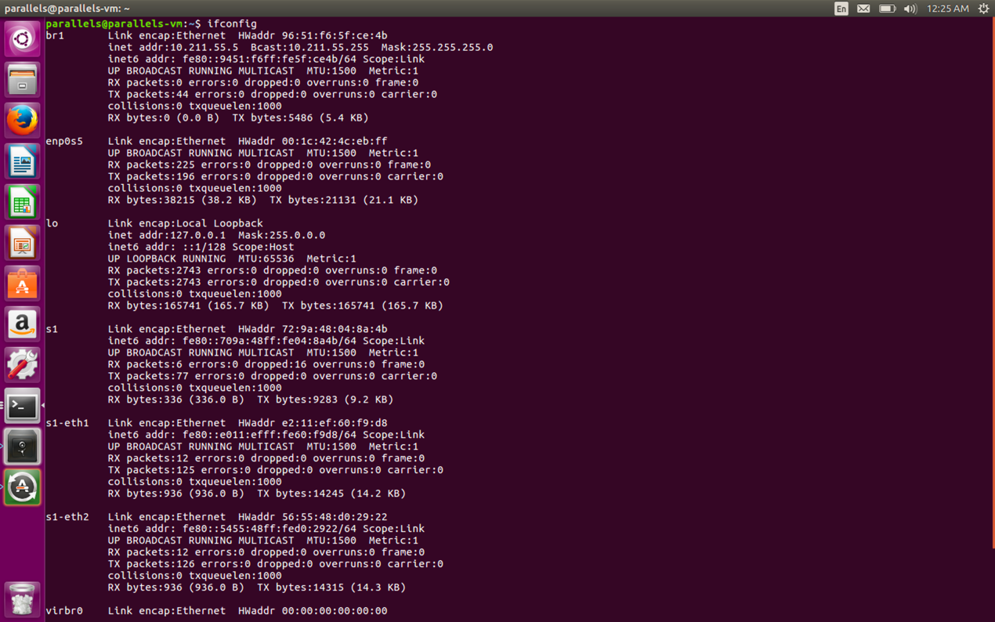

Figure 5 Execute ifconfig on VM1

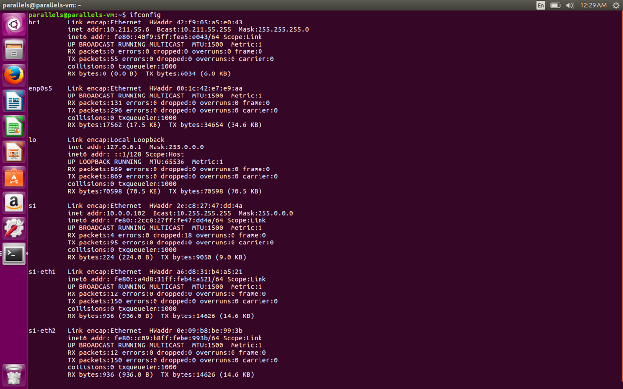

Figure 6 Execute ifconfig on VM2

* 1. Create Vxlan

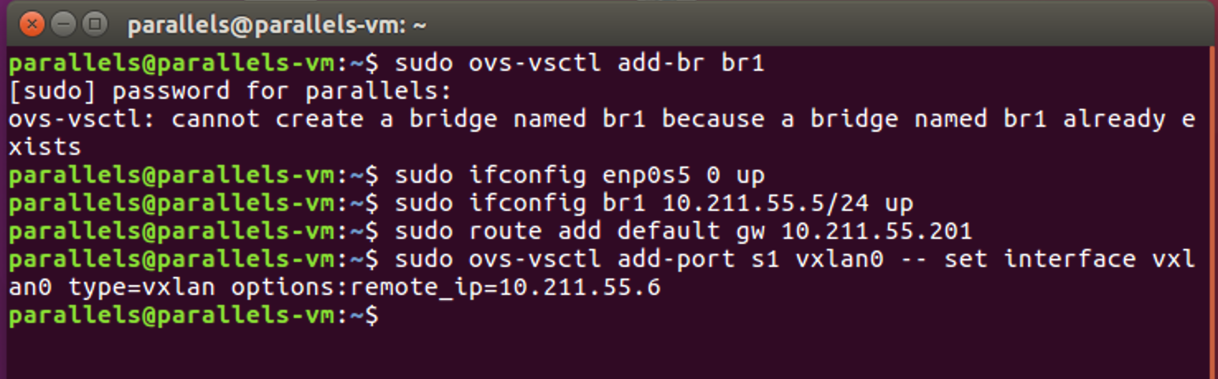

Figure 7 Create Vxlan on VM1

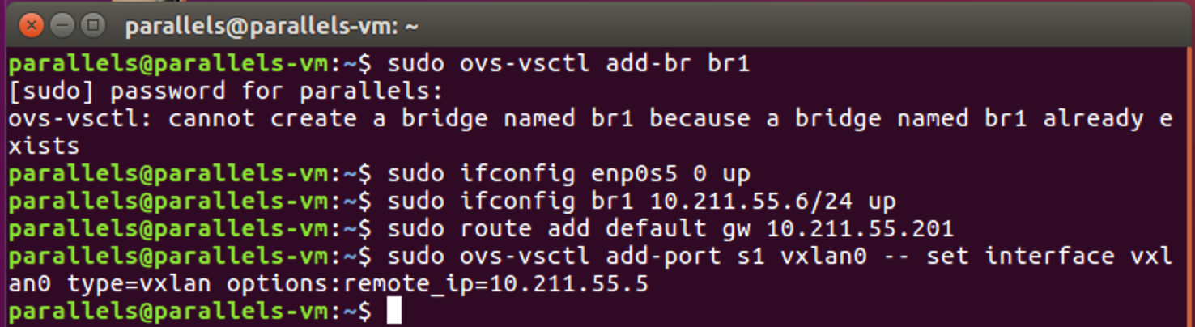

Figure 8 Create Vxlan on VM2

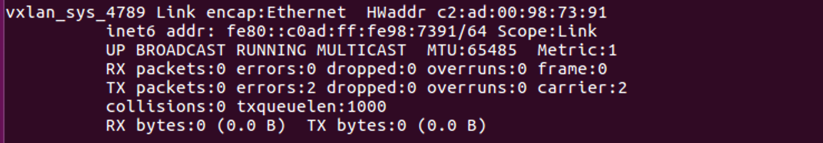

Figure 9 Execute ifconfig on VM1

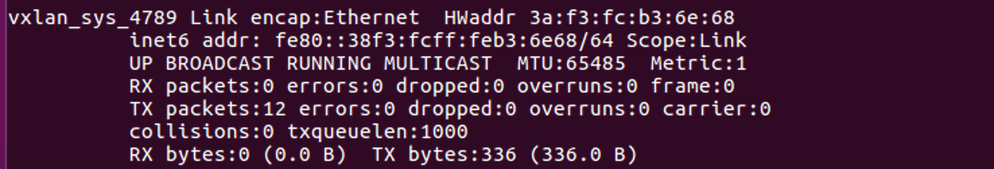

Figure 10 Execute ifconfig on VM2

However, after all these preparation, VM1 still can not connect to VM2 through vxlan. I can not figure out why.

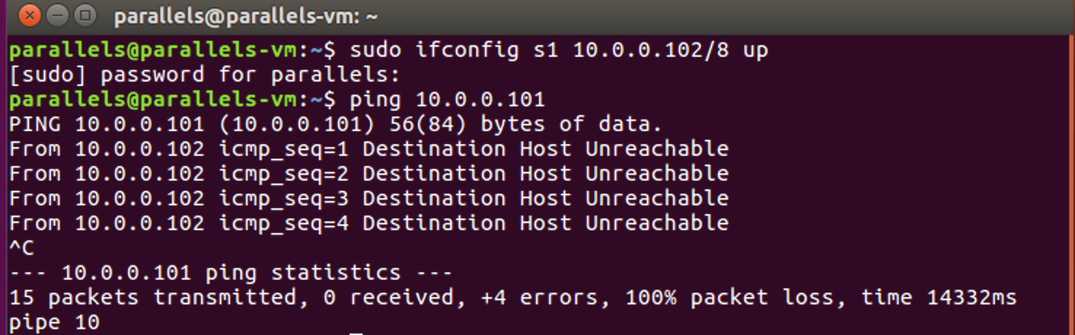

* 1. Another method

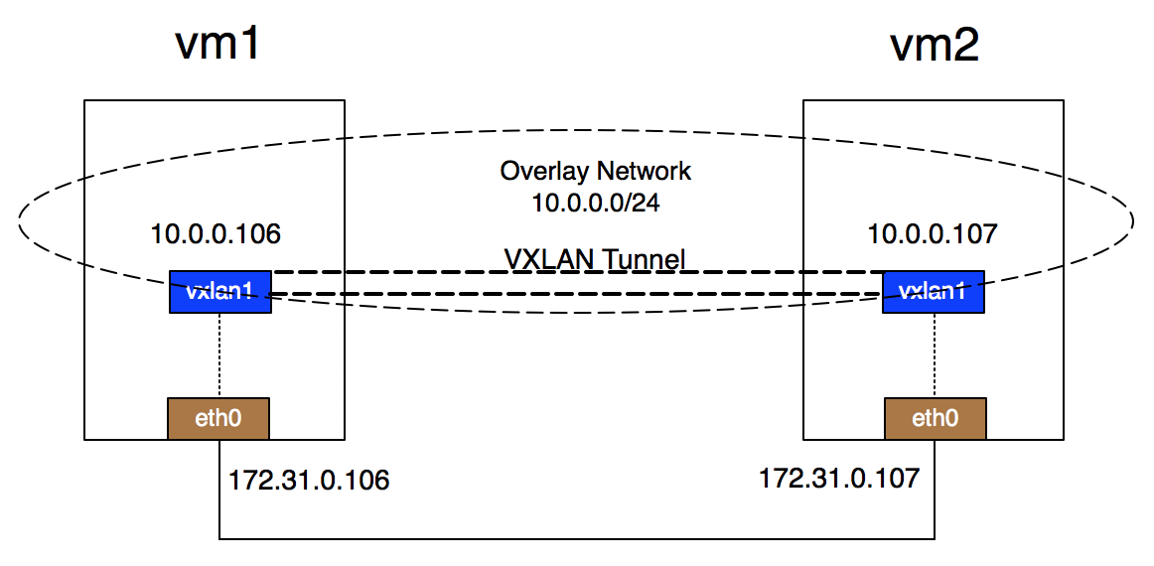

Figure 11 Point to point vxlan

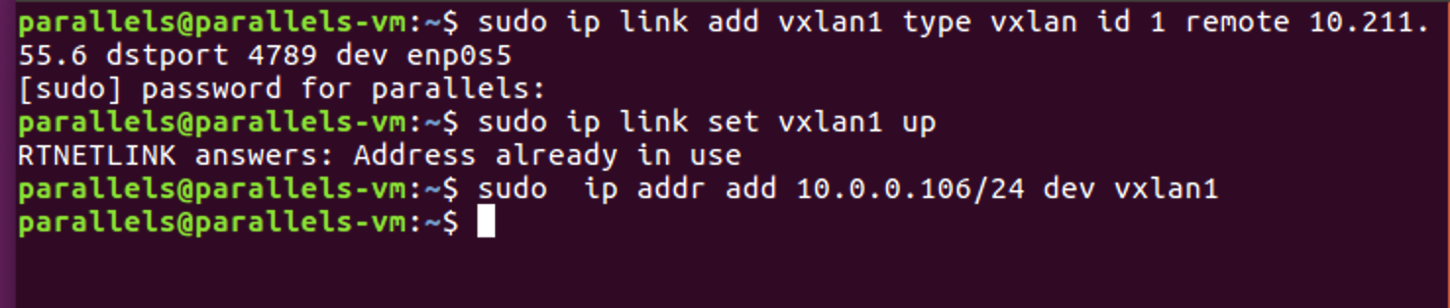

Figure 12 Create Vxlan on VM1

The first command above creates a network interface of type vxlan on Linux called vxlan1.

**Remote**: to encapsulate and unseal vxlan messages as a vtep device, you need to know which peer vtep to send the encapsulated vxlan messages to. On Linux, group can be used to specify multicast group address, or remote can be used to specify peer unicast address. In the experimental cloud environment, multicast is not supported by default. Here, remote is used to specify the peer-to-peer IP address of 172.31.0.107.

**Dstport**: Specifies the destination port as 4789. Because when vxlan was first implemented in Linux kernel version 3.7, UDP port was not specified. Many vendors use the port 8472, and Linux uses the same port. Later, IANA assigned 4789 as the destination UDP port of vxlan. If you need to use the IANA port, you need to specify it with dstport.

**Dev**: Specifies the physical device through which vtep communicates, using eth0. The second command sets vxlan up.

The third command assigns IP address 10.0.0.106 to the device, and the subnet mask is 24 (255.255.255.0).

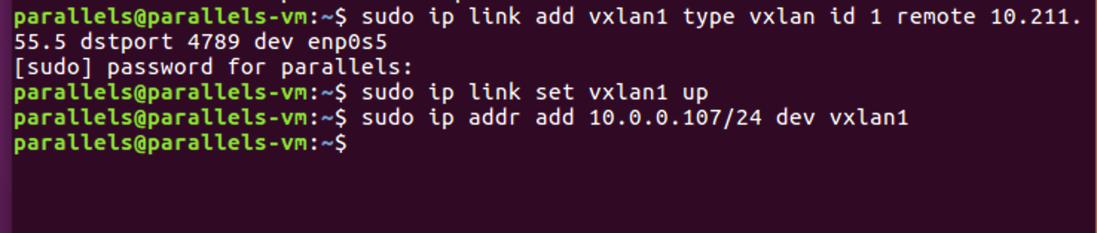

Figure 13 Create Vxlan on VM2

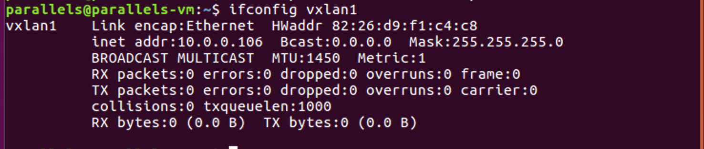

Figure 14 Execute ifconfig on VM1

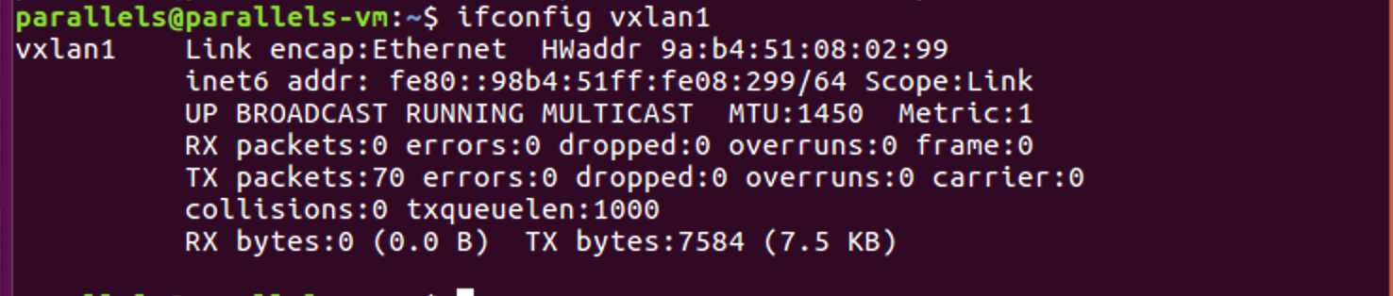

Figure 15 Execute ifconfig on VM2

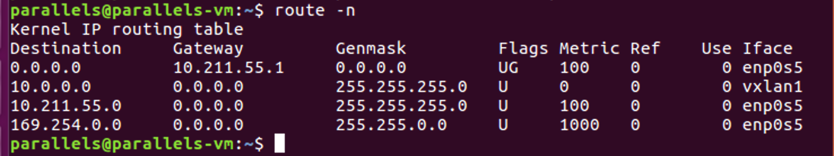

Figure 16 Check routing table (Existence of vxlan)

* 1. Use Wireshark to monitor the interfaces s1 and eth0

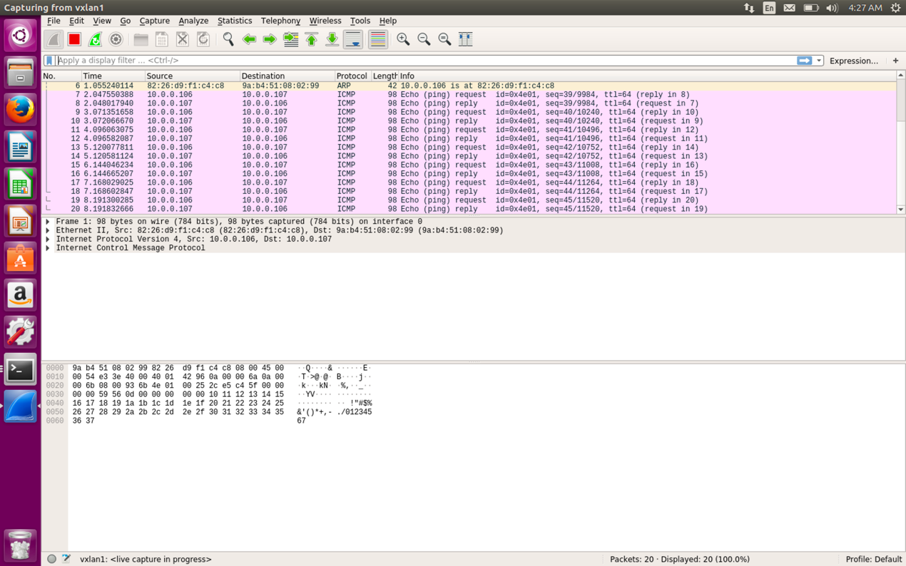

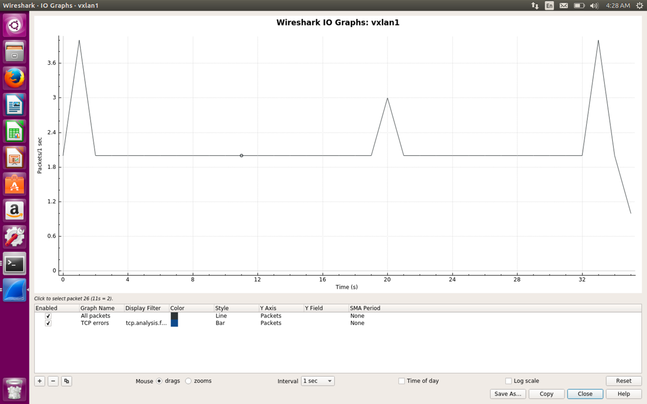

Figure 17 Monitor the interface s1

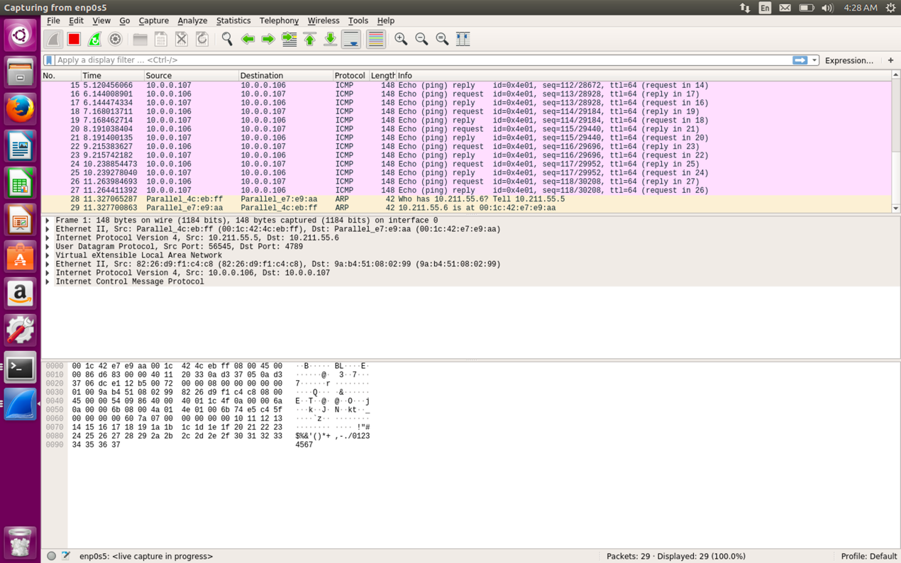

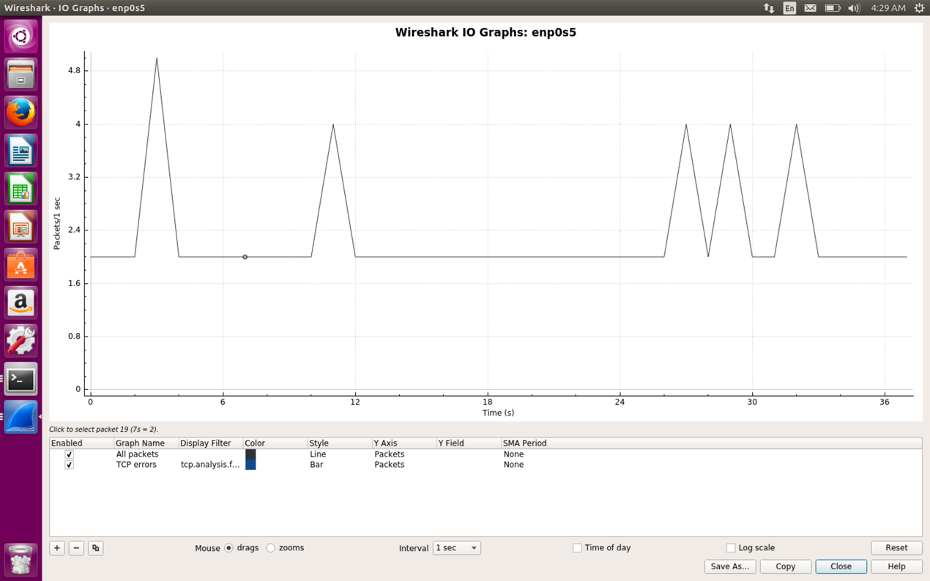

Figure 18 Monitor the interface enp0s5

Compare the above two figures, we can find that the flow through the interface enp0s5 is almost the same as the flow through the interface s1.

The reason is that the interface s1 (vxlan1) is constructed by the interface enp0s5 as the following figure shows:

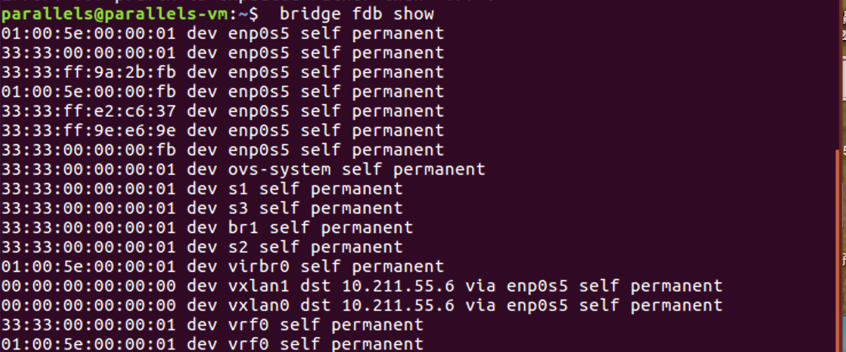

Figure 19 FDB table

* 1. Use iperf to test the network bandwidth between the two virtual machines

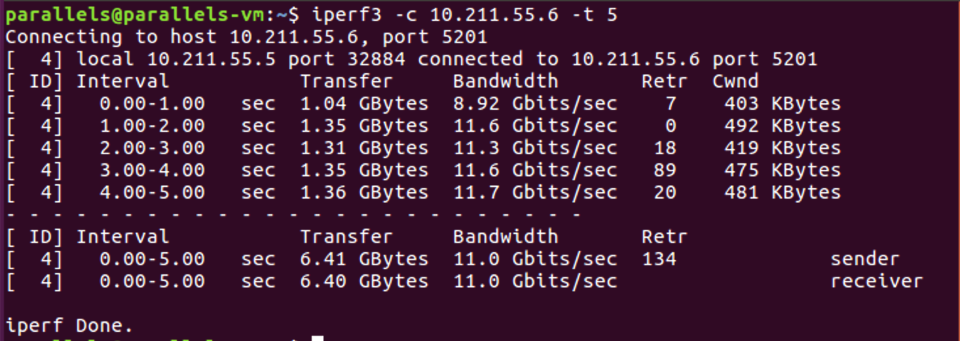

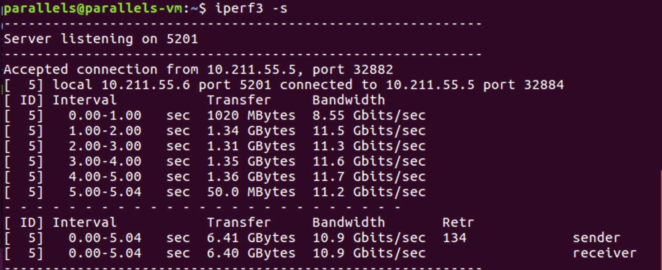

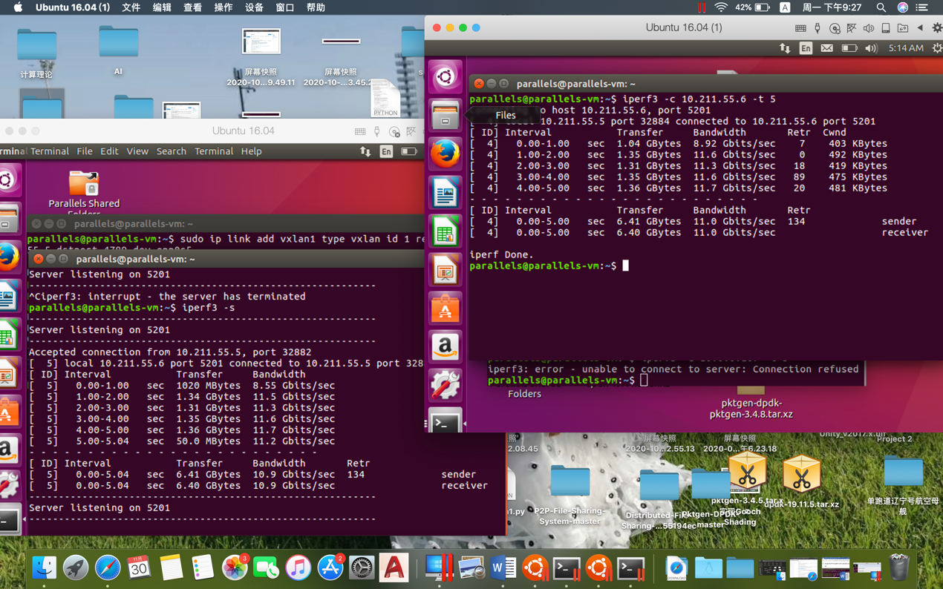

* 1. Use ping to test the network latency

